Update 13

Saturday 24, 2011

Friday, Chris Langdon, Alysha Coppola, Alan Foreman, Kristy Mctaggart, Tammy Macdonald and Carmen Rodriguez helped to answer questions as Alison and I gave a tour to Mr. Andre Share, the Director of Oceans and Coasts Research from the Dept. of Environmental Affairs in South Africa. Thank you to them and many others who volunteered, help answer questions and otherwise made themselves available.

Later, Captain Mark Pickett and James Brinkley hosted Ambassador Donald Gips, his wife and two of their three sons (see photo below).

Finally, Assistant Secretary of Commerce Michael Camunez and guests visited the ship. The assistant secretary was surprised and honored that there was a special flag aloft identifying his presence.

On the Repairs: By Friday morning, all the expected pieces of equipment for the repair had arrived at the ship. Unfortunately, the adapter plates for the steering motors were not the correct size. Friday afternoon, the ship’s agent located a local engineer to adjust the adapter plates to fit. The company worked all night and delivered them early Saturday morning. The modified adapter plates were deemed unacceptable to the engineer from the United States responsible for the repair (cracks in the welds were clearly visible). The Brown lead Engineer has contacted another company that believes they can produce and deliver suitable adapter plates tomorrow, Sunday.
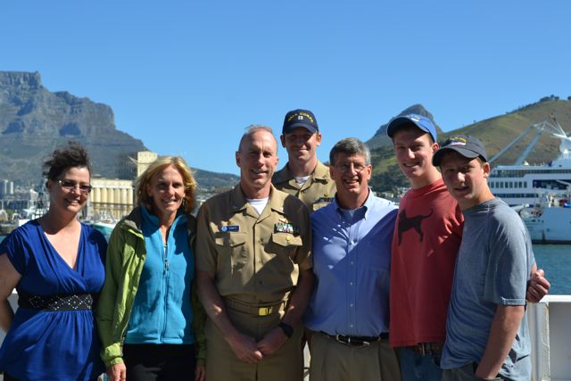
There has been no official departure date set, but there remains some possibility that the ship will sail on Sunday, however unlikely. I appreciate all your efforts to continue to stand-by.

The galley is closed all day Saturday and Sunday.
Attached: Photo of Ambassador Gips and his family with the Captain, Ops. Officer and Chief Scientist.

NOTE:
If the ship does not sail Sunday, it is my understanding that the following people may have some issues with their continued participation. These people are:

1. O2 - Chris Langdon.
2. LADCP – Sarah Eggleston.
3. CFC analyst - Alan Foreman.
4. Phytoplankton Brazilian collaborator – Rafael Araujo

If that happens, we have worked out some contingency planning to readjust people’s work assignments. All week, we have been working out some cross-training for various people changing work assignments. I appreciate all your work making that possible, volunteering and otherwise having such a positive and flexible attitude; if nothing else, I know we have all gained a better understanding of each others responsibilities.
We are evaluating if we will be able to complete the cruise despite these loses or will require replacement personnel. We hate to lose anyone.

